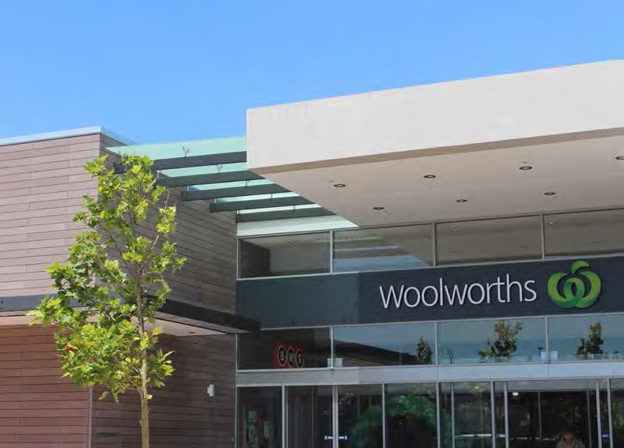

**A true village lifestyle at the centre of it all.**

**The award-winning Village at Wellard is a close-knit community where life’s essentials are all within easy reach.**

Nearby, you’ll find a range of schools, with a future primary and high school within the estate, and Peter Carnley Anglican Community School just a short drive from home.

Here, you’ll enjoy a connected village lifestyle like no other. Less than 5 minutes’ walk takes you to the Village Centre, which boasts a range of shops including Woolworths,

Priceline, Subway and more. Add to this a café, services and a proposed tavern – all right on your doorstep.

Homesites in the Village Centre South Stage 3 Release are located near a future landscaped park, which will be the perfect setting for those lazy weekend days. With so much on your doorstep, including the established cities

of Mandurah, Rockingham and Fremantle, don’t miss your opportunity to live a true village lifestyle at The Village at Wellard today.

Wellard Train Station is just a short walk away from home and puts the Perth CBD an easy 28-minute train ride away.

**thevillageatwellard.com.au**

**RELEASE PLAN**

VILLAGE CENTRE SOUTH 3

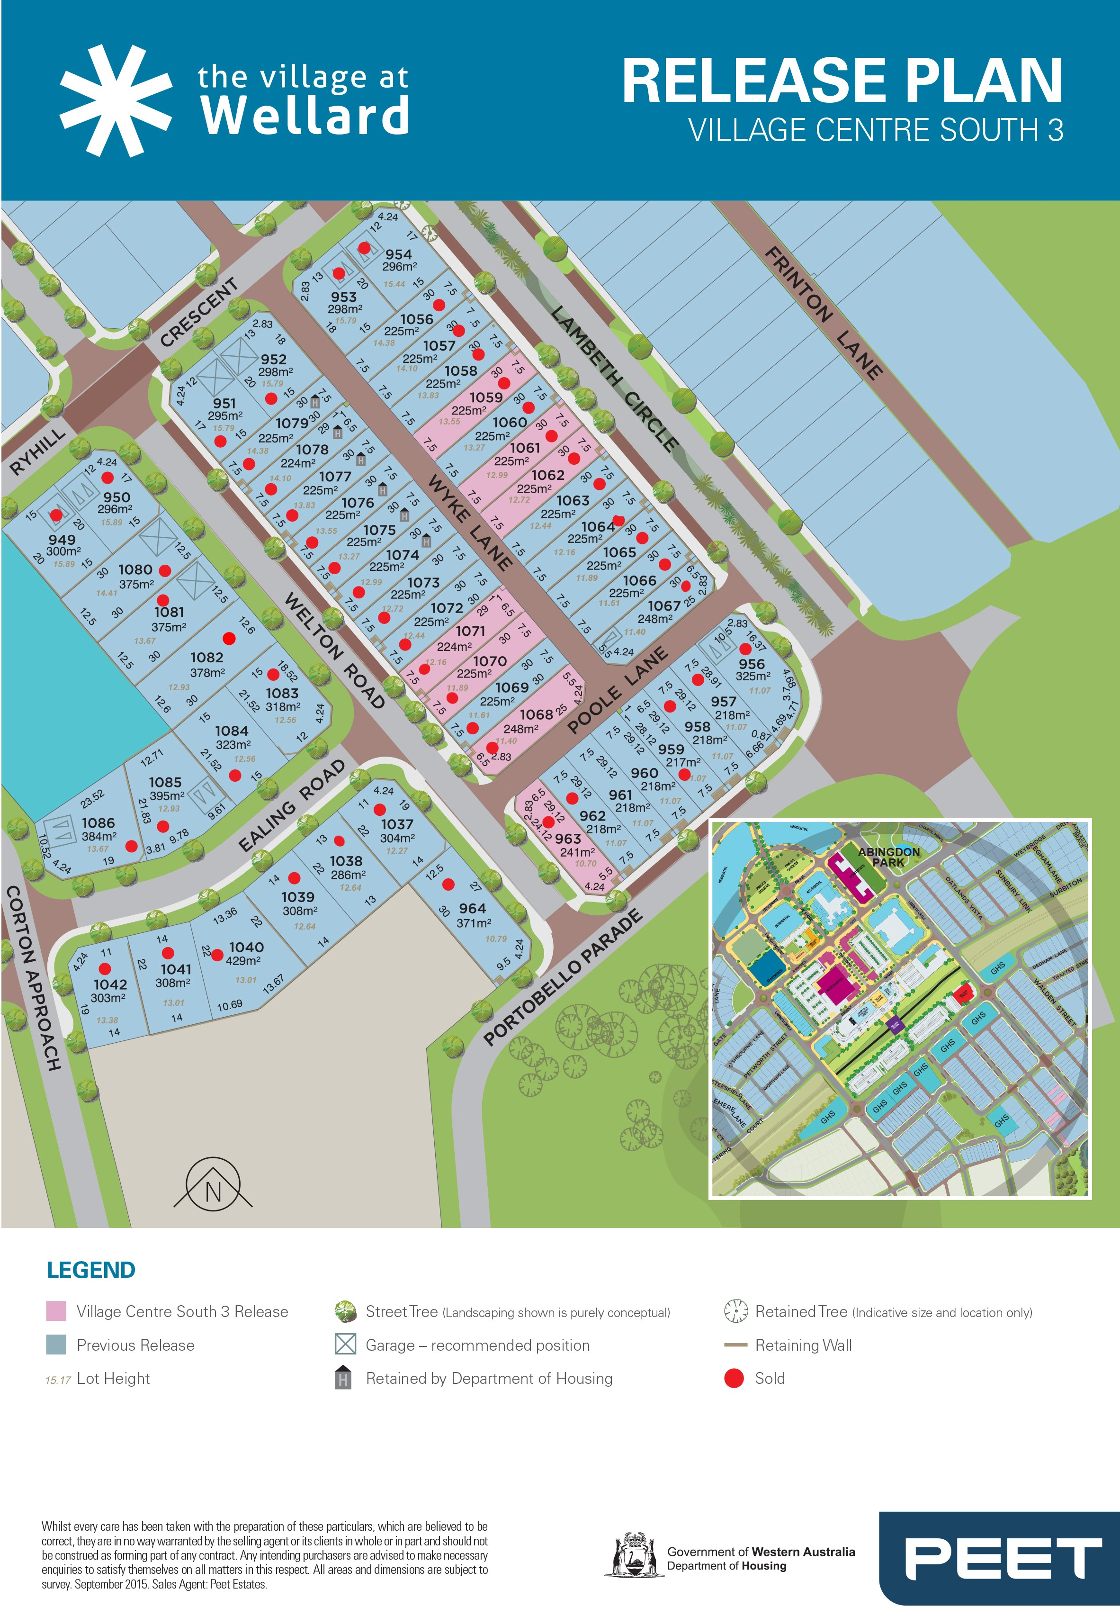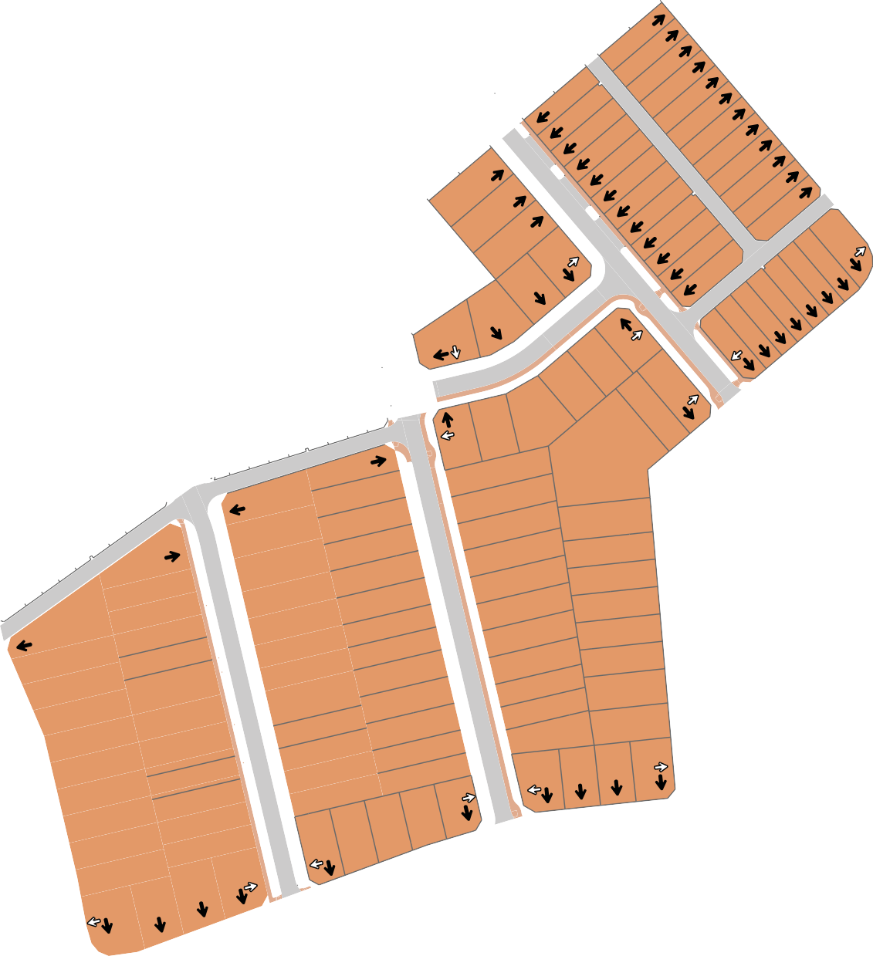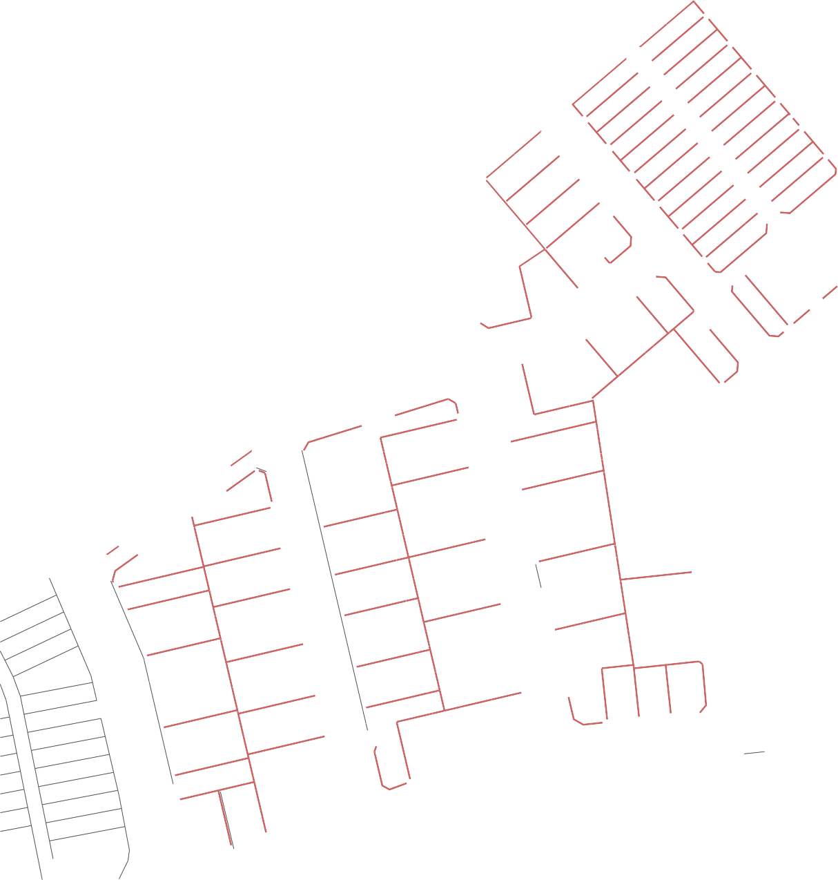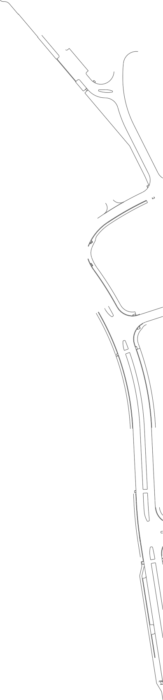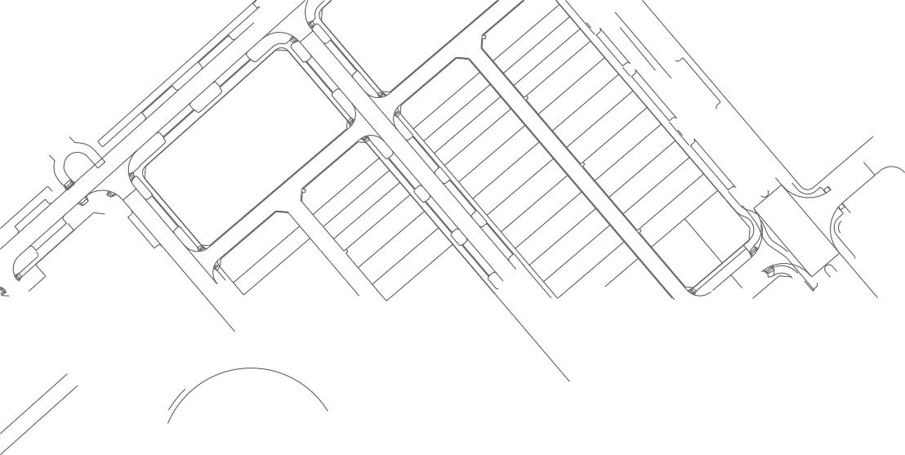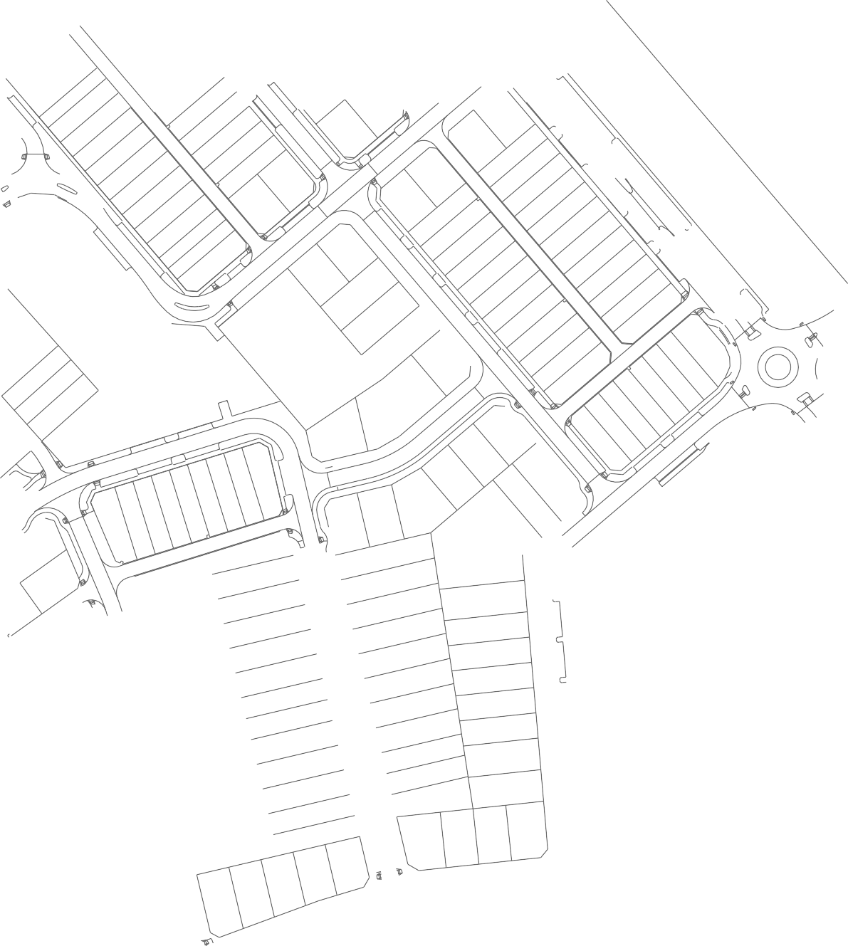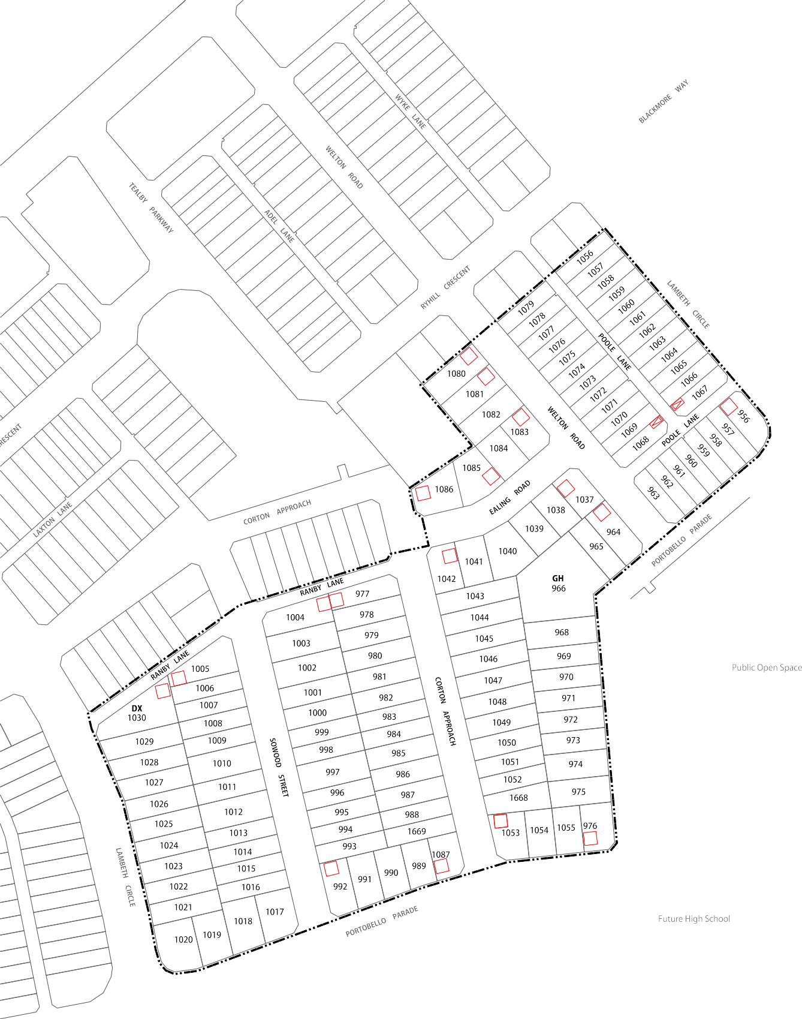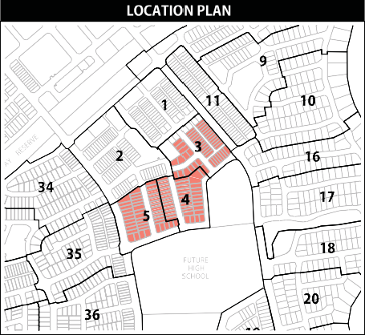

19/09/2016

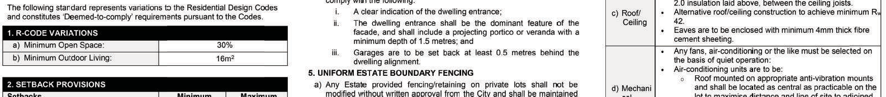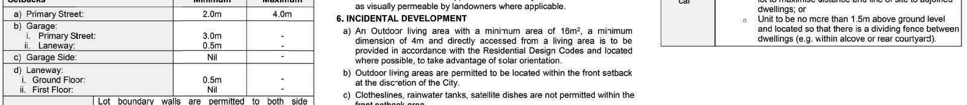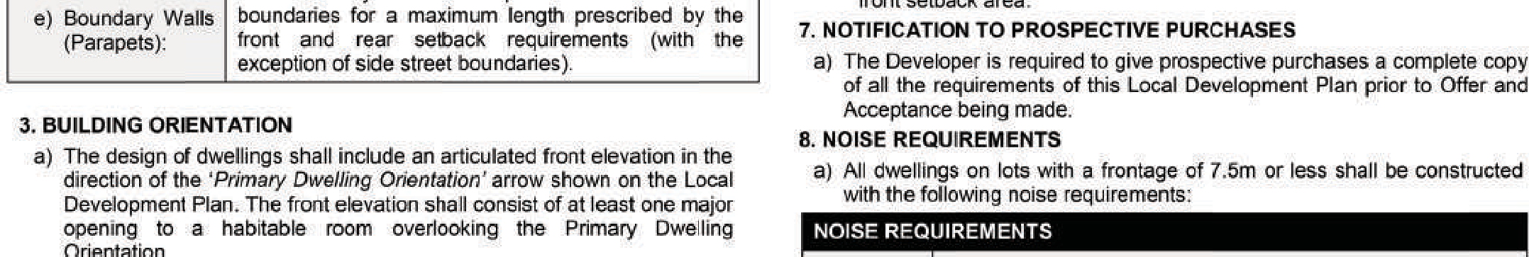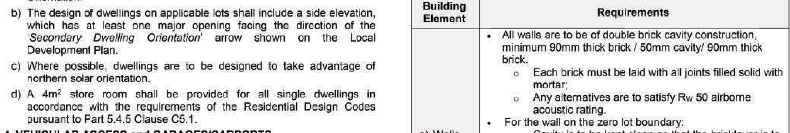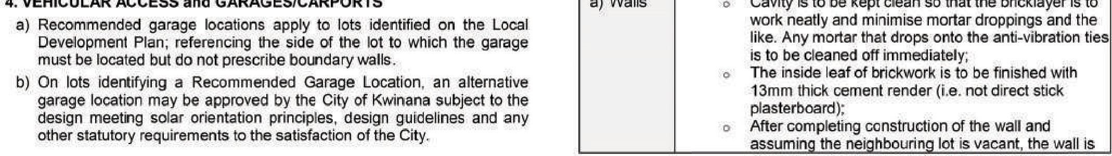

19/09/2016