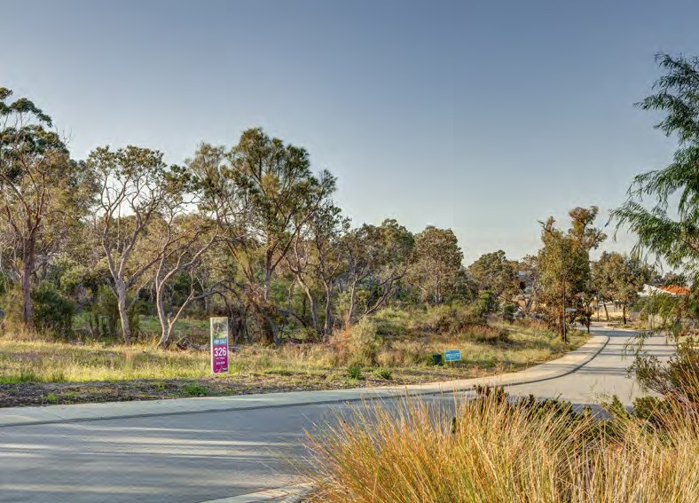

**Experience the best of both worlds.**

**The Village at Wellard is a vibrant estate offering life’s conveniences within a stunning natural environment. With a train station at its heart and a Village Centre boasting Woolworths and a range of specialty shops, cafes and services, everything you need is right on your doorstep.**

space you need to build your dream home, peace and quiet is yours to enjoy.

Available blocks are located just a short walk from the Village Centre and Wellard train station and minutes from a choice of established schools, beaches and recreational facilities. Closer to home, over 30 hectares of landscaped parks, 17 hectares of natural bushland and 10 hectares of

conservation wetlands provide a stunning natural backdrop.

Providing a true village lifestyle, The Village at Wellard is just a 28-minute train ride from the Perth CBD, and an easy drive from the nearby cities of Fremantle and Rockingham.

It’s these touches and more that make the Village at Wellard an active, healthy and vibrant community, where living life to the full comes easy.

Blocks are now selling, allowing you to enjoy the best of both worlds. Surrounded by natural bushland and all the

**thevillageatwellard.com.au**

**RELEASE PLAN**

HOMESTEAD RELEASE

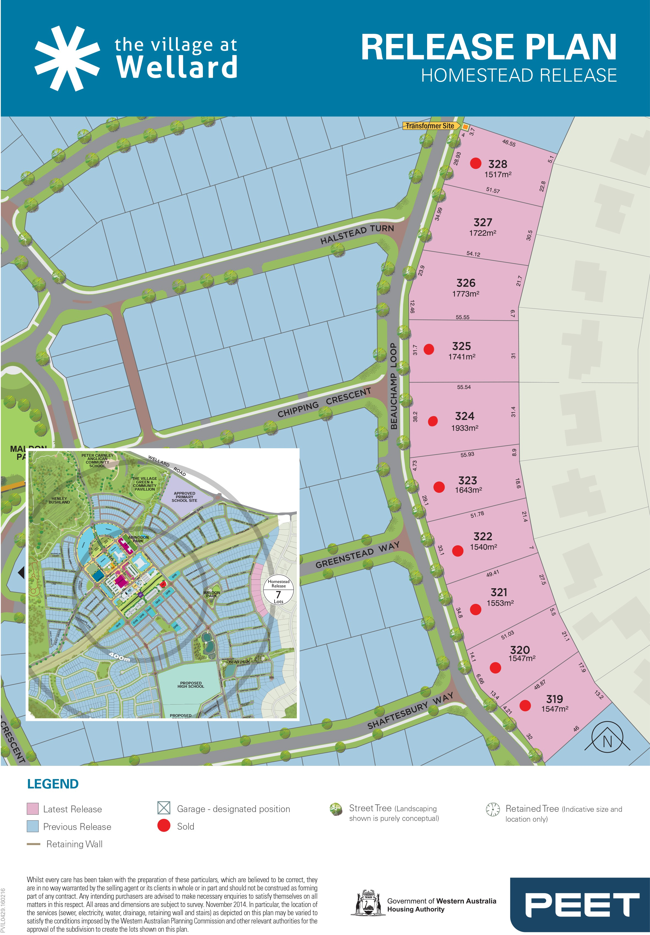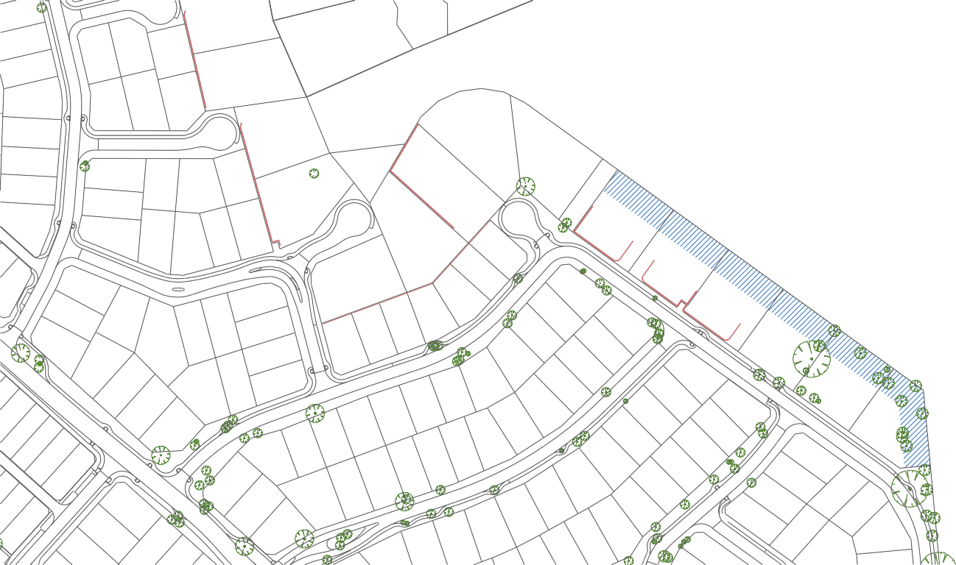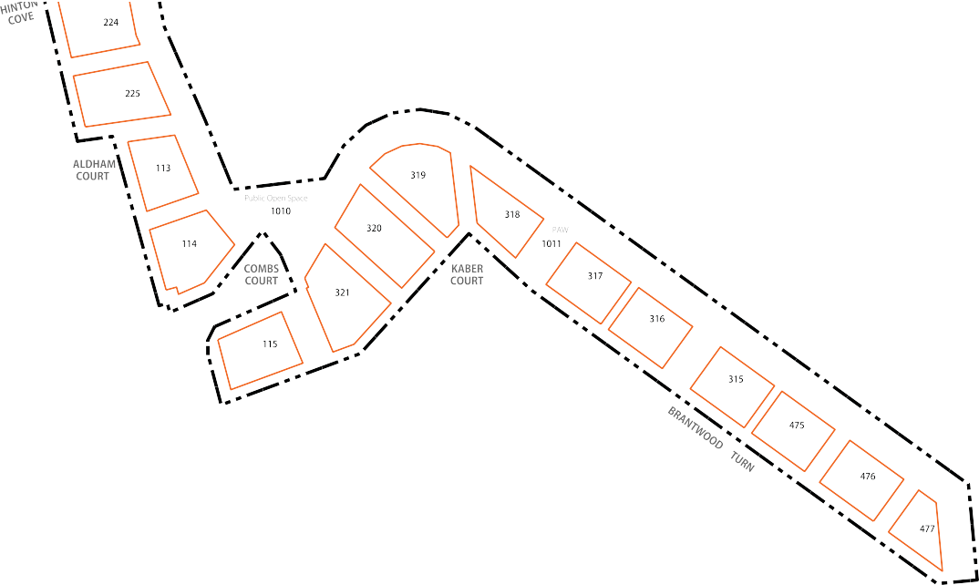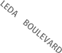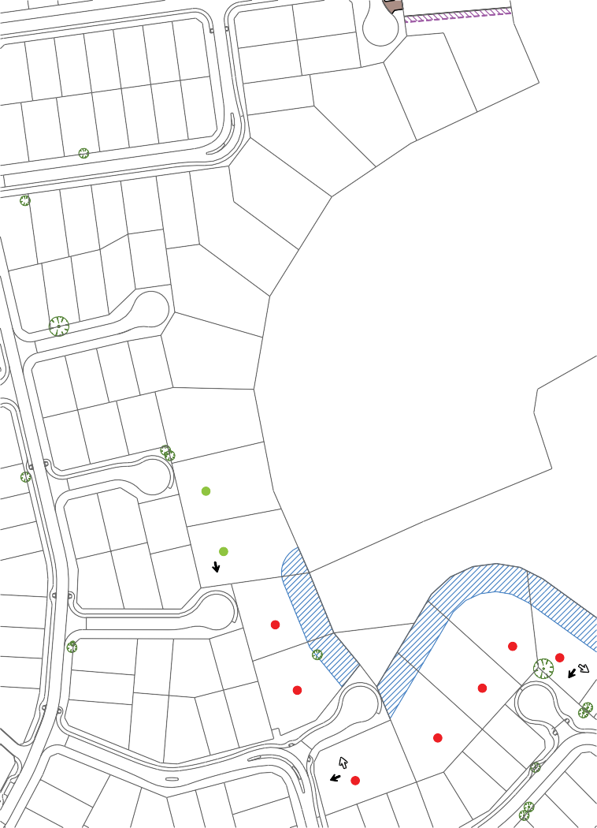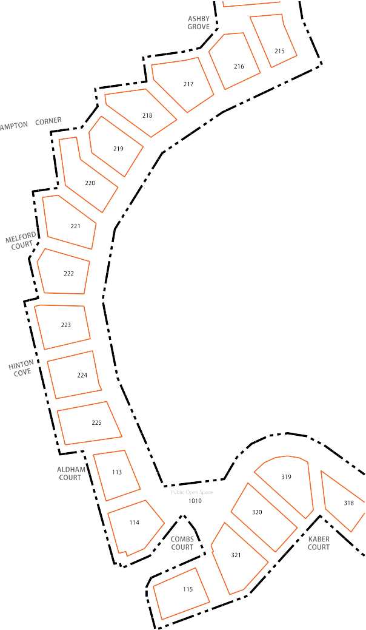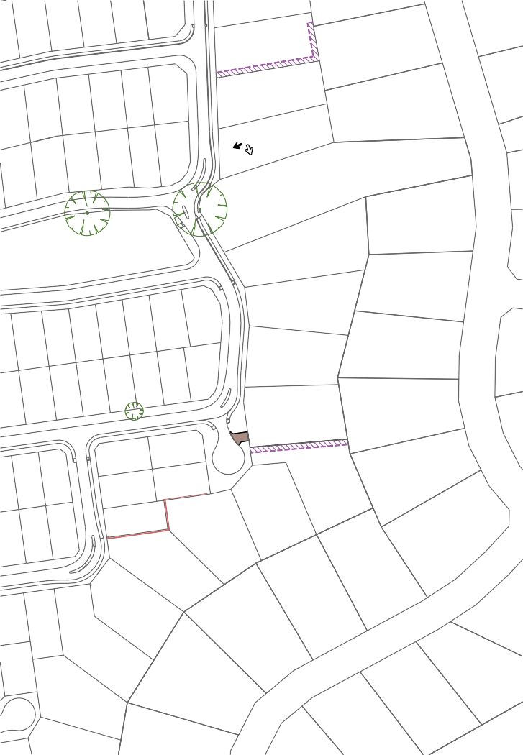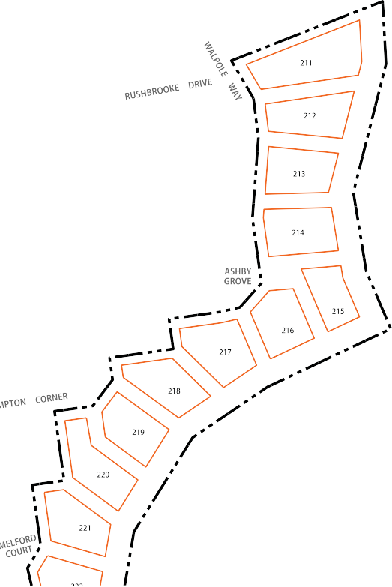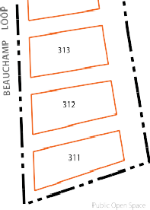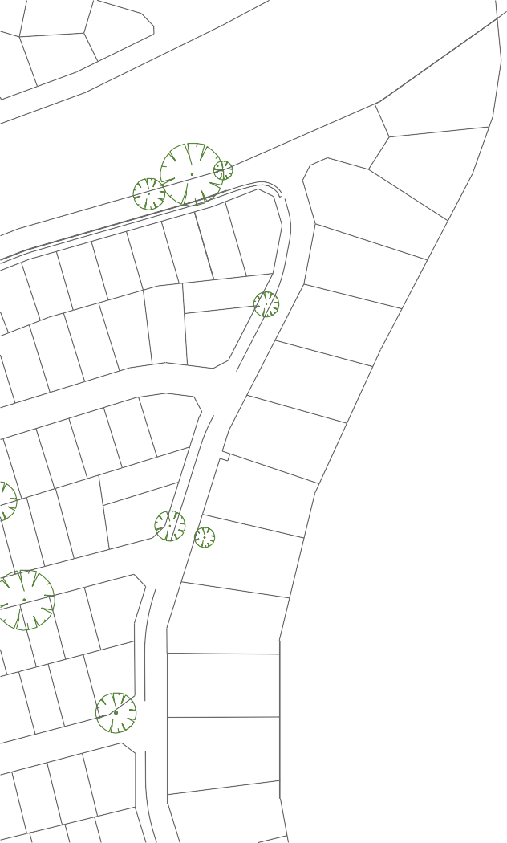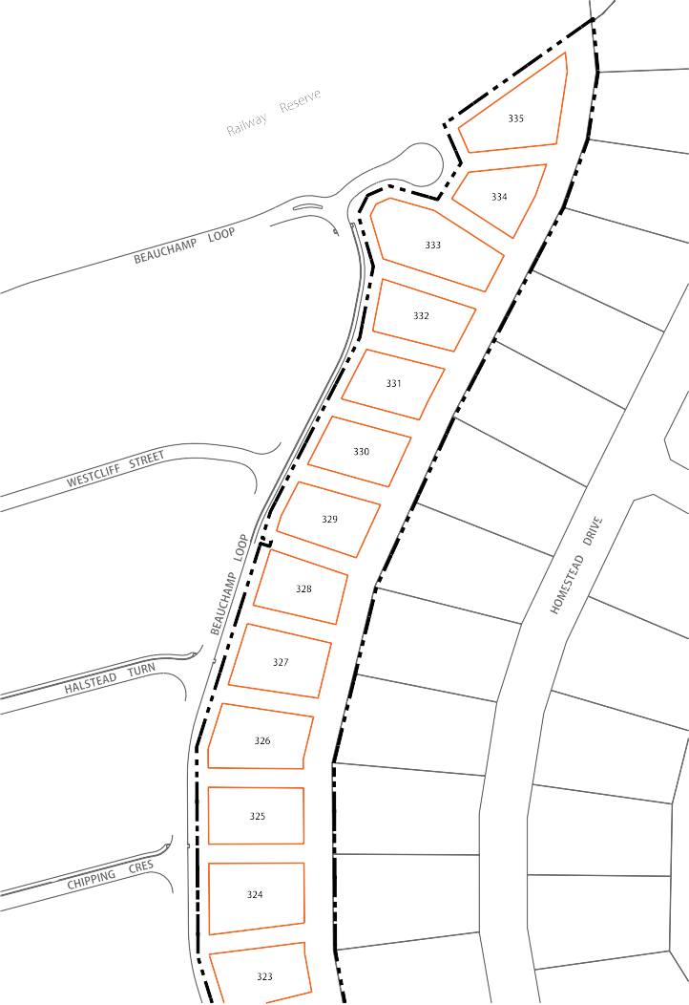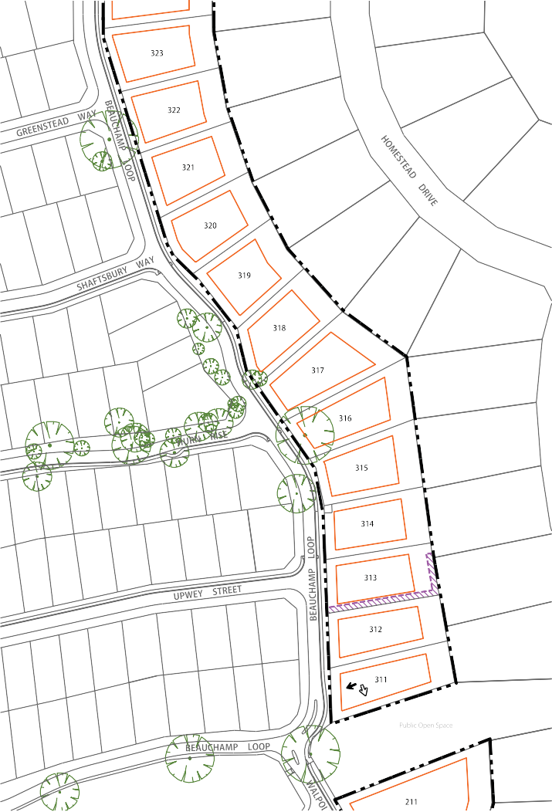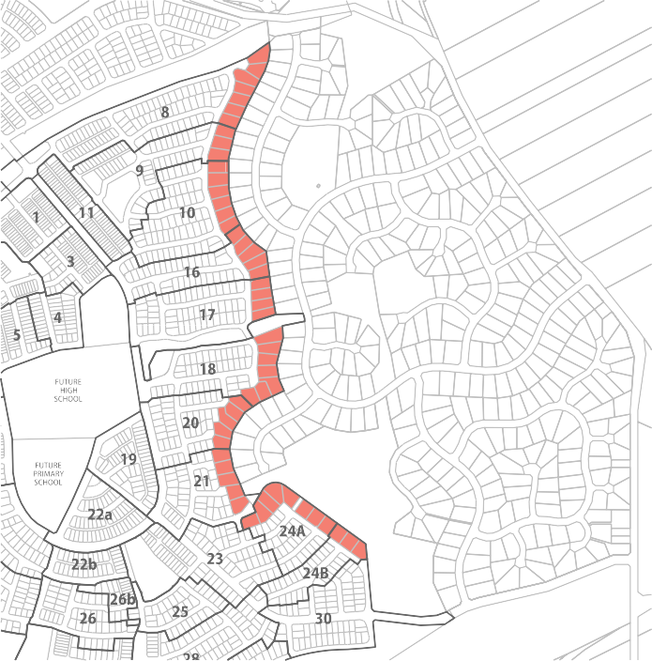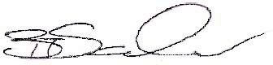

10 April 2015

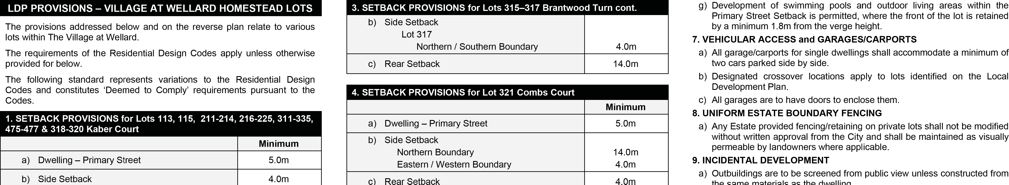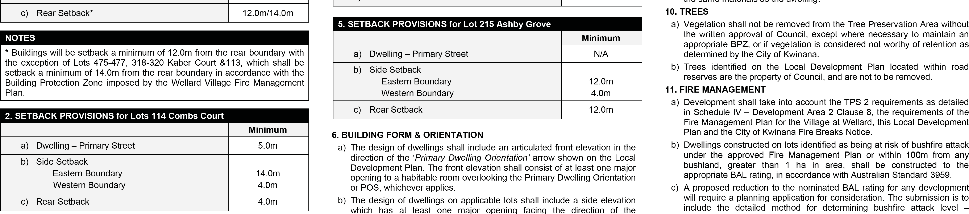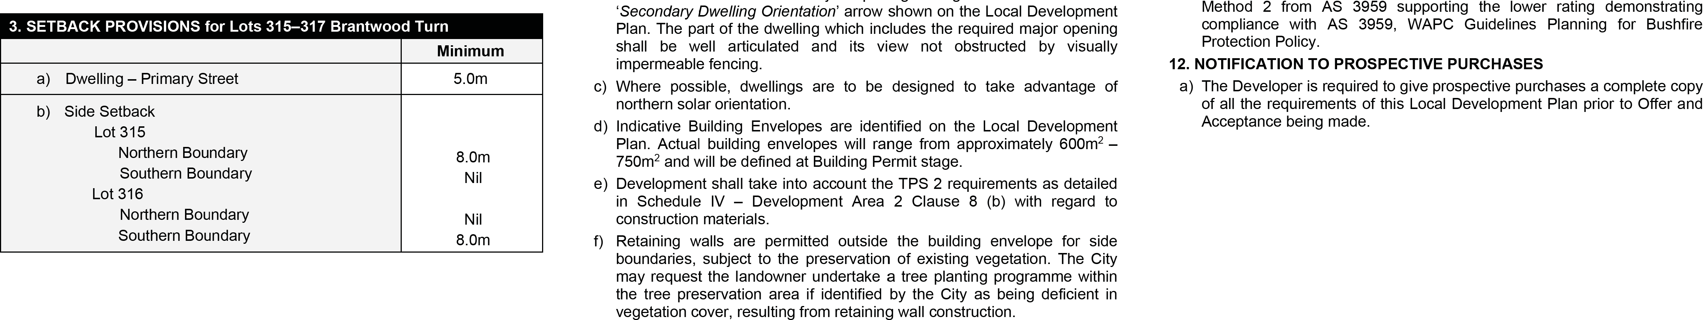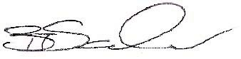

10 April 2015